**Practical-1**

**Aim:** Writing Python programs in various modes and printing and assigning values assigned to python.

1. **Executing simple commands in python command prompt:** Opening python in command prompt mode allows to directly input the code and gives the result instantly.

🡪Printing something in the console screen

print(“Hello”) or print(‘Hello’)

🡪Using exponents in python

4**2 will produce square of the number 4

🡪floating point division and floor division

1. floating point division

5/2 will return 2.5

1. floor division

5//2 will return 2

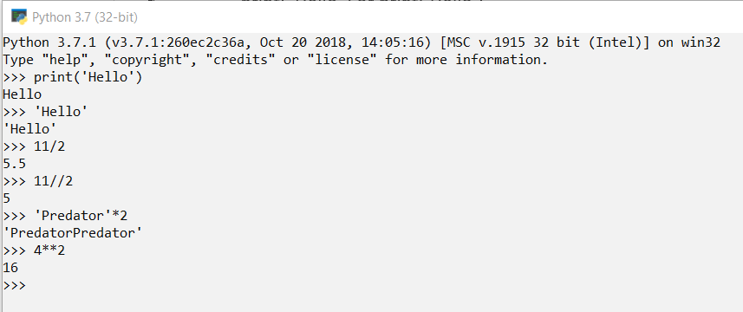

1. **Executing simple commands in Python IDLE Shell:**

IDLE is integrated development environment (IDE) for editing and running Python 2.x or Python 3 programs.

The IDLE GUI (graphical user interface) is automatically installed with the Python interpreter. IDLE was designed specifically for use with Python.

IDLE has a number of features to help you develop your Python programs including powerful syntax highlighting.

🡪**Opening python IDLE Shell**

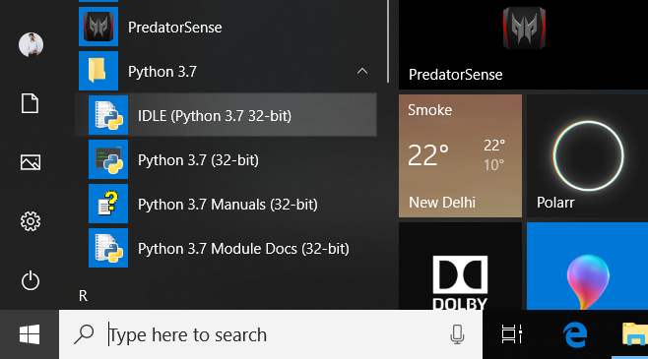

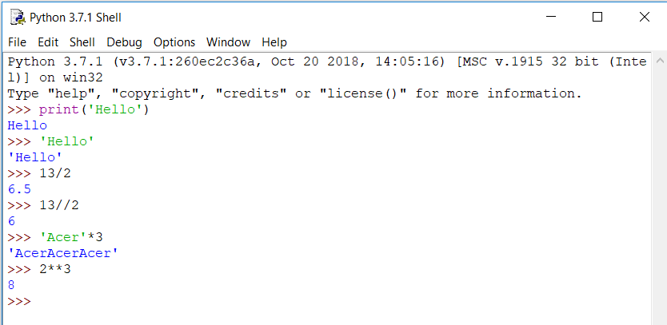

1. **Writing a program in script mode:**

**🡪Opening script mode:** In the standard Python shell you can go to “File” -> “New File” (or just hit Ctrl + N) to pull up a blank script in which to put your code. Then save the script with a “.py” extension.

To run the script, either select “Run” -> “Run Module” or press F5.

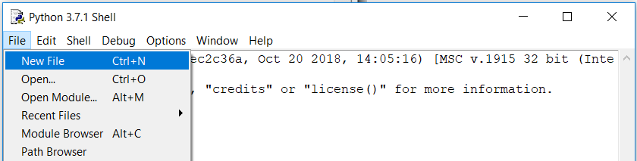

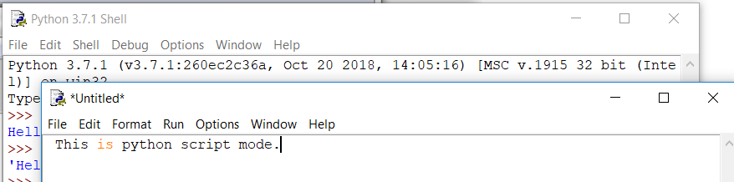

**🡪** The python script mode is useful for running multiple lines of codes at once because the python IDLE Shell doesn’t allow to run multiple lines of code.

**🡪Example program in script mode:**

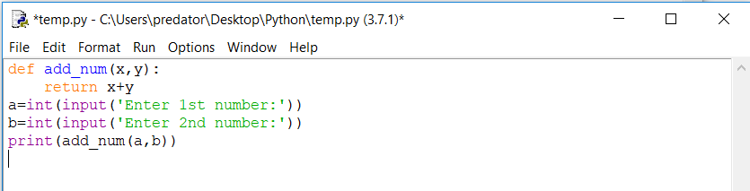

**Output of the above code:**

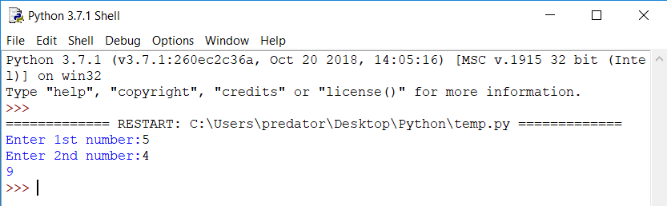

1. **Program using variable and assignment:**

>>> x=1

>>> y=2

>>> print(x,y)

1 2

1. **Program to demonstrate single value to multiple vaiables:**

>>> a=b=c=2

>>> print(a,b,c)

2 2 2

1. **Program to assign multiple values to multiple variables:**

>>> a,b,c=5,10,15

>>> print(a,b,c)

5 10 15

1. **Program to assigning values to variables:**

>>> x=5

>>> print(x)

5

>>> name='Rahul'

>>> print(name)

Rahul

>>> salary=36000.67

>>> print(salary)

36000.67

>>>